KORESPODENSI IOP

CREATIVE THINKING PROFILE OF STUDENTS IN COMPLETION OF MATHEMATICAL PROBLEMS REVIEWED FROM THE TYPE OF PERSONALITY OF MYER-BRIGGS DIMENSION

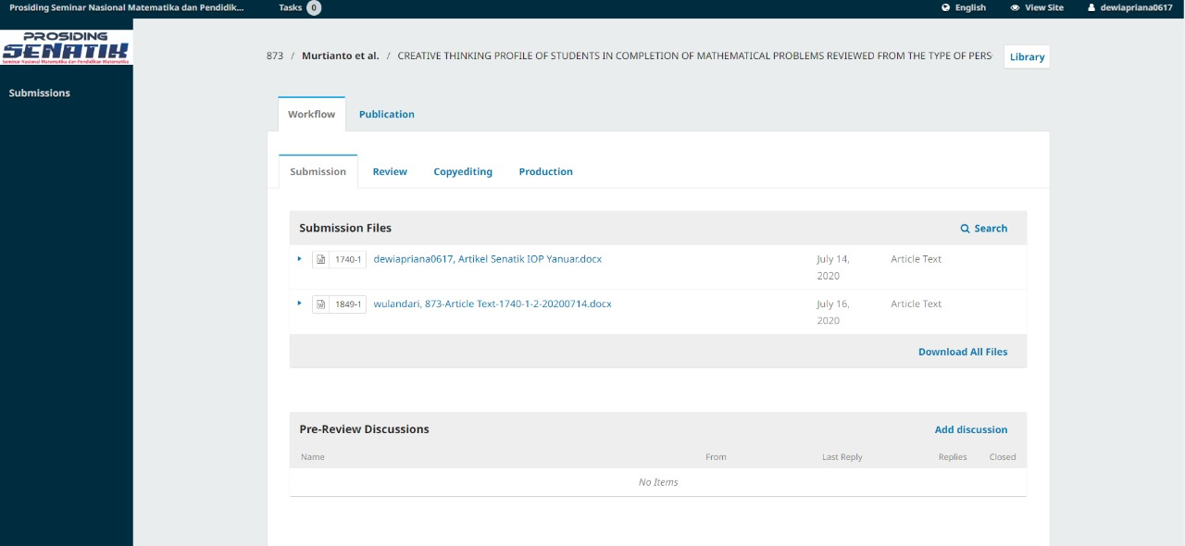

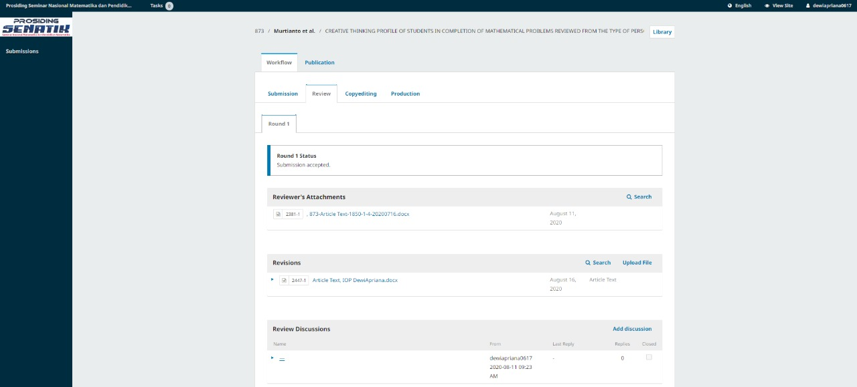

CREATIVE THINKING PROFILE OF STUDENTS IN COMPLETION OF MATHEMATICAL PROBLEMS REVIEWED FROM THE TYPE OF PERSONALITY OF MYER-BRIGGS DIMENSION

ABSTRACT
Creativity is a 21st Century skill that is needed by everyone. Creativity is born from the ability to think creatively. Personality The Myer Briggs' dimension consists of 4 types of guardian personality: students like coherent and systematic learning. Artisan students like active learning. Rational students love the knowledge that uses logic. This study aims to determine students' creative thinking abilities in solving mathematical problems in terms of the personality type dimensions of Myer-Briggs. The method used in this research is to use qualitative methods. Data collection was carried out in three stages, using questionnaires, written tests, and interviews. The survey was distributed throughout class VII with 256 students, and then one student was taken from each Personality. The results showed that: (1) the personality types of students can improve students' creative thinking patterns, (2) Mathematical problem solving for each number 1,2,3 of the Guardian subjects was categorized level 3,4,4. Artisan subjects were classified as level 0,1,3. Rational items are categorized level 3,3,4. Idealist subjects are categorized as level 3,3,4.
Keywords: Creative Thinking, Personality Myer-Briggs dimension.

- Introduction
The era of the industrial revolution 4.0 is an era where the quality of human resources is needed in everyday life. The challenges faced in the age of the industrial revolution are improving the quality of human resources who can compete in that era and the need to strengthen the nation's character (Sujadi, 2018). In the period of the industrial revolution 4.0 had several challenges namely; (1) information technology security targeting the world of education; (2) the reliability and stability of increasingly sophisticated production machines; (3) lack of adequate skills; (4) there will be a loss of automation work (5) the use of increasingly sophisticated technology (6) curriculum changes, method models, strategies, approaches, and teachers in learning that reinforce new uneven literacy. The development of the industrial revolution era 4.0 is marked by the development of digital technology, artificial intelligence, big data, robotic (Ibda, 2018). The rapid growth of technology for the past two decades has dramatically influenced the mathematic learning system (Murtianto, 2019)
In the era of the industrial revolution, 4.0 mathematical skills are needed to develop student character, which is often referred to as 4C (Communication, Collaboration, Critical Thinking, and Problem Solving, Creativity, and Innovation). Student character development which is commonly referred to as 4C as follows: Communication is learning that can not be separated from the form of communication between students and students, students and teachers, which includes, elaboration of what concepts are learned, an explanation of arguments or opinions in solving a mathematical problem, proof which is logical towards solving a problem. Collaboration is student learning always packaged in groups. Critical thinking and problem-solving are the formation of critical thinking skills, creative and innovative, as well as the ability to solve problems (Prasetyo & Trisyanti, 2017). Mathematical problems can be related to issues in everyday life. Creativity and innovation are the formations of a creative and innovative mindset. Students will get used to thinking to solve a problem (Wardono & Indrawati, 2019). An act of creative thinking can occur if the thinker reaches a sudden conclusion that is new to him, which can be artistic, mechanical, or administrative production. Productive thinking can occur or be owned by anyone, even though what has been produced by someone else (Murtianto, 2019)
In everyday life, related to solving mathematical problems poured in the form of flat wake problems. Mathematical thinking is essential for teaching mathematics. The thinking process is an activity occurring in the human's Brain, Murtianto (2019). The flat build material is sturdy for students to understand, primarily material about the flat build area of a combination of flat builds. The flat build material is challenging for students to understand, mostly substantial about the flat build area of a mix of flat builds. Area or circumference without understanding how the area or circumference formula is obtained, which causes a lack of student knowledge about concepts and procedures in solving problems about the flat area (Indayani et al., 2015). Issues are things that students definitely encounter in learning. One crucial aspect that needs to be known by the teacher in the success of education is to understand the students' ability to solve a problem (Ruliani,2018).
Based on the results of observations and interviews with one of the mathematics subjects in SMP N 8 Semarang, students often experience difficulties in solving mathematical problems. Students tend to use formulas or by using quick methods rather than using procedural steps for accurate completion. In the process of learning mathematics, students must be guided and accustomed to doing activities in finding and gaining understanding. Student-centered learning will undoubtedly allow students to seek knowledge and solutions in working on a problem that can improve students' creative thinking abilities (Ulandari, et al., 2019). The ability to think creatively is something that is possessed from birth. Innovative thinking must be developed in order to have a great mindset. (Azhari, 2013). Someone in facing the progress and development of the times really needs the ability to think creatively. In the event of technology and information, it cannot be denied that it is the result of students' creative thinking abilities (Sa'adah, et al., 2019). Mathematics is a science that is used as a tool to foster mathematical skills and student activity (Auliya, et al., 2019).
Personality comes from the English "personality." The figure is an intricate component of self-formation that consists of ego, personal unconscious, the collective unconscious. Personality is a unique adjustment to the environment determined by the dynamic organization of psychophysical systems in the individual. Isabel Brigg Myers and her mother Katharine C. Briggs developed a personality model based on Carl Jung's theory of 16 dimensions and taken four personality types from the combination of each of the four aspects. David Keirsey named the Keirsey temperament sorter (KTS). There are four personality types, namely, guardian types like the traditional class model. Artisan students are always active in all circumstances and still want to be considered by the teacher and by his friends. Objective type students like explanations that are based on logic, and they are able to capture abstractions and material that requires high intellect. Idealist type students prefer to complete assignments individually rather than doing tasks in groups (Putra, 2017). Based on this, researchers are interested in examining more deeply how students think creatively in solving a problem. Besides, researchers also want to explore whether personality factors influence the level of students' creative thinking abilities.

- Method
The research was conducted at SMP Negeri 8 Semarang in class VII students. This type of research is descriptive qualitative. Taking the subject using sampling techniques and using time triangulation. The instrument used by researchers was the Myer-Briggs dimension personality questionnaire, creative thinking tests, and interviews. The personality questionnaire used consisted of 70 items of a statement; the first thinking test consisted of 3 items. First, the researcher distributed 256 Myer-Briggs personality questionnaires to grade VII students. Each Personality is taken one subject that represents that Personality. In the second stage, the researcher gave a test of creative thinking to the chosen theme. And the next step in this researcher interviewed to believe the results that have been obtained.

- Results and discussion
Results
Determination of the subjects in this study was the first to distribute questionnaires to all class VII, namely VII-A, VII-B, VII-C, VII-D, VII-E, VII-F, VII-G, and VII-H which consisted of 256 students in SMP Negeri 8 Semarang. Based on a questionnaire that has been filled out by students according to their circumstances, used as an initial stage to classify the Personality of the Guardian, Artisan, rational, and idealist, The following is a personality questionnaire chart at SMP Negeri 8 Semarang.

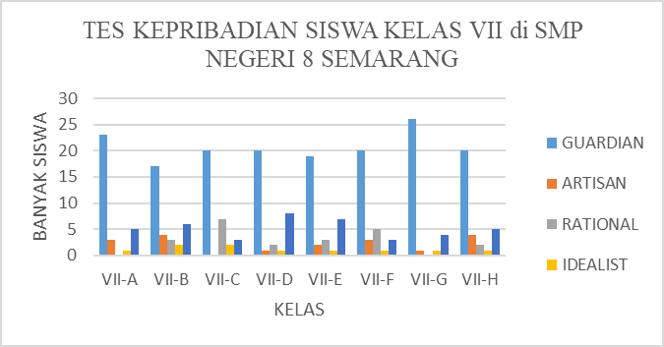

Graph 1 Student Personality Questionnaire Results

Discussion

Graph 2. Personality Percentage of Middle School Students

In graph 2 about the personality tests of grade VII students at SMP Negeri 8 Semarang, data is obtained that explains that the Guardian personality type is more dominant in SMP N 8 Semarang. That is because the teacher is more dominant in teaching mathematics using a nice, ordered, and systematic way with conventional learning methods. Artistan's personality type is caused by a lack of dialogue between students who lack understanding and the teacher related to the lesson so that only students who master the material being taught can play an active role in the teaching and learning process.
In the Rational Personality type, this was caused by problems given by the teacher lacking variety, so students can work on the issue following the example problems that have been discussed. This resulted in students lacking the ability to solve problems using logic. In the Idealist personality type caused by the K13 curriculum, students are required to solve problems in groups. This results in students preferring to resolve issues of discussion and lack of trust held to solve these problems individually.
Creative thinking is a mathematical ability that includes fluency, authenticity, and elaboration. Fluency is the ability students have to answer math problems correctly. Flexibility is the ability students have to solve mathematical problems in non-standard ways. Authenticity is the ability students have to answer mathematical questions using their ideas or their language. Elaboration is the ability of students to expand answers to mathematical problems and bring up new issues or new ideas. (Dilla, et al., 2018). The ability to think creatively is the ability to produce or develop something new from designs that have been provided by others. (Ulandari, et al., 2019). Creative thinking, according to the Guardian, Artisan, Rational, and Idealist personalities, namely:
- Students with Guardian Personality
This Guardian type student likes traditional classes along with regular procedures. Students with this type prefer instructors by explaining the material clearly and clearly, giving real and precise instructions. Students are more likely to complete assignments on time because students prefer to make plans before solving a problem. In this study, a researcher found something new, namely, in the first problem, students worked on the issues with a detailed and systematic formula, but students did not write down the description of the equation. Students write how to solve it by substituting what was known in the problem. Subjects work with steps and calculations that are precise and sequential. If the matter has not found an idea to solve the problem, the issue will tend to be silent; after the view appears, the subject immediately works following what was seen. This is by Putra (2017), who says that students are more likely to complete assignments on time because students prefer to make plans before solving a problem.
In research into creative thinking to solve mathematical problems and interviews in solving problems. Guardian students can only work on question number 1 by finding a new answer fluently, but not being able to come up with more than one alternative solution or not being able to come up with several unique ways. So students in working on question number 1 are categorized as having a level of creative thinking that is level 3, which means creative (Siswono, 2011).
In questions, number 2 and number 3 Guardian students can work on an interview a mathematical problem by having more than one answer. The resulting solution is an easy and flexible answer. So students in working on questions numbers 2 and 3 are categorized as having a level of creative thinking, which is level 4, which means very creative (Siswono, 2011).
- Students with Artistan Personality
Students with the type of Artisan prefer change do not like stability. Students with this type are always active wherever they are and still want to be the attention of everyone, both friends and teachers. The class form they like is classes that are demonstrations, presentations, discussions because then students can show Artistan's abilities. In this study, researchers found something new, namely in the first problem, the students working on the difficulty experienced a concept error. They incorrectly substituted what was known in the issue. So it can be seen that these students do not like the concepts that have existed in mathematics learning and it can be assumed these students do not like stability or hurry. This is by Melya (2018) that students in doing something want to be done in a hurry, and get bored quickly in monotonous teaching techniques.
In research into creative thinking to solve mathematical problems and interviews in solving problems. Artistan students in question number 1 students experience errors in solving a problem caused by concepts related to the problem, not understood or remembered correctly. Then students are categorized as level 0 is not creative (Siswono, 2011).
In question number 2 the level 4 category students are very creative because students work using two different and fluent ways of solving question number 3 Artistan students by finding a new answer fluently, but unable to come up with more than one alternative solution or unable to come up with several unique ways. So students in working on question number 3 have a level of creative thinking that is level 3, which means creative (Siswono, 2011).

- Students with Rational Personality
Rational students like learning that is based on logic. Students catch the material faster, observe problems, students run the strategies given by the teacher systematically; students always look for additional equipment from various sources related to the content. Objective type students prefer giving individual assignments; the most preferred subjects are science, mathematics, philosophy. In this study, researchers found something new, namely a problem presented by students able to solve using logic and strategies taught by the teacher systematically. So this student is categorized as having a Rational personality. This is consistent with Melya (2018) that Rational types like learning that was based on logic. Students catch the material faster, observe problems, students run the strategies given by the teacher systematically.
In research into creative thinking to solve mathematical problems and interviews in solving problems. Rational students in problem number 1 students can find an answer with new, but unable to come up with more than one alternative solution or unable to come up with more than one alternative way of answering or unable to come up with several new ideas. Then the students are categorized as level 3, namely creative (Siswono, 2011).
In question number 2, students can devise different (flexible) ways to get different answers, even though the solutions are not new. Then the students are categorized as level 3, namely creative (Siswono, 2011). In question number 3, students can solve a problem with more than one alternative answer or can come up with several new ways to find answers fluently and flexibly. Then the students are categorized as level 4 that is very creative (Siswono, 2011).

- Students with Idealist Personalities
Idealist types prefer material about ideas and values. Idealist students like to complete assignments individually rather than groups. Creativity is an essential part of an idealist because he prefers a small class where each member knows each other. In this study, researchers found something new, namely a problem given by these students make observations first before solving the given problem. Solving these problems, students have high confidence in what students do without regard to the opinions of others. This is supported by this student who has an elevated mind and spirit when solving problems. So students assume that the answer itself is the right answer (Khamidah & Suherman, 2016).
In research into creative thinking to solve mathematical problems and interviews in solving problems. Idealist student number 1 students can find an answer with new, but unable to come up with more than one alternative solution or unable to come up with more than one alternative way of explanation or unable to come up with several new techniques. Then the students are categorized as level 3, namely creative (Siswono, 2011).
In question number 2, students can devise different (flexible) ways to get different answers even though the solutions are not new. Then the students are categorized as level 3, namely creative (Siswono, 2011). In problem number 3, students can solve a problem with more than one alternative answer or be able to come up with several new ways to find answers fluently and flexibly. Then the students are categorized as level 4 that is very creative (Siswono, 2011).

- Closing
The results of the research and discussion conclude that:
- Based on the Myer-Briggs dimension personality questionnaire, 165 Guardian personality types were obtained with a percentage of 64.45%. This is caused by learning in the dominant school using this Personality. Artistan's Personality is 18 students, with a rate of 7.03%. This is caused by the lack of communication between students related to classroom learning. Rational Personality numbered 22 students with a portion of 8.59%. This is caused by the problems given lacking variance. Idealist Personality is only ten students with a percentage of 3.90%. This is because the K13 curriculum is demanded to solve problems in groups.

- The profile of the Guardian subject solves mathematical problems by arranging one or two ways, and the resulting method is fluent and flexible. The issue worked on the problem in detail and systematically. So the subject of Guardian in question number 1 is categorized as level 3, namely creative. In questions number 2 and 3, level 4 is classified as being very creative. The profile of Artistan's subject solves mathematical problems by arranging one or two ways, the resulting method is fluent and flexible, but there are misconceptions made by Artistan's subject. Students cause this tends to be in a hurry and get bored quickly in solving these problems. So the item Artistan in question number 1 is categorized as level 0, which is not creative. In question number 2, level 4 is classified as being very creative. In question number 3, level 3 is categorized as creative. The profile of the Rational subject solves mathematical problems by arranging one or two ways, the resulting method is fluent and flexible, but some answers are not new. That is caused by the Rational subject using his logic to solve the problem. So the Rational issue is number 1, and level 3 is categorized as creative. In question number 3, level 4 is classified as being very creative. Profiles of the Idealist subject solve mathematical problems by arranging one or two ways, the methods produced are fluent and flexible, but some answers are not new. So the Idealist subject in question number 1, 2 are categorized as level 3, namely creative. In question number 3, level 4 is classified as being very creative.

Recommendation
The recommendation that can be submitted by researchers relating to the results of the research are:
- The school should facilitate students in the Myer-Briggs dimension personality test to create teaching and learning activities that can be adjusted based on the Personality of each student.
- We recommend that teachers often provide math problems that can develop creative thinking, and students are asked to do following the Personality they have. So it's not limited to the use of ways to solve mathematical problems.
- To the academic community, the need for further research on personality test personality dimensions Myer-Briggs.

Bibliography
Auliya, N. N., Ariyanto, L., & Murtianto, Y. H. (2019). Pengembangan Bahan Ajar Model Problem Posing Tipe Post Solution Berbantuan Microsoft Mathematics terhadap Berpikir Kreatif Matematis Siswa SMP. Imajiner: Jurnal Matematika dan Pendidikan Matematika, 50-55.
Azhari, 2013. Peningkatan Kemampuan Berpikir Kreatif Matematik Siswa Melalui Pendekatan Kontruktivisme di Kelas VII Sekolah Menengah Pertama (SMP) NEGERI 2 Banyumasin III. Jurnal Pendidikan Matemtaika Volume 7 No.2 Juli 2013.
Dilla, S. C., Hidayat, W. & Rohaeti, E. E., 2018. Faktor Gender dan Resiliensi Dalam Pencapaian Kemampuan Berpikir Kreatif Matematis Siswa SMA. Journal of Medives, pp. 129-136.
Ibda, H., 2018. Penguatan Literasi Baru Pada Guru Madrasah Ibtidaiyah Dalam Menjawab Tantangan Era Revolusi Industri 4.0. JRTIE: Journal of Research and Thought of Islamic Education.
Indayani, S., Kusmyadi, T. A. & Usodo, B., 2015. Profil Pemahaman Siswa Terhadap Luas Dan Keliling Bangun Datar Yang Digunakan Dalam Memcahkan Masalah Matematika Ditinjau Dari Kecerdasan Emosional. Elektronik Pembelajaran Matematika, 3(3), pp. 326-337.
Khamidah, K. & Suherman, 2016. Proses Berpikir Matematis Siswa dalam Menyelesaikan Masalah Matematika DItinjau dari Tipe Kepribadian Keirsey. Jurnal Pendidikan Matematika, 7(2), pp. 231-248.
Murtianto, Y. H., Muhtarom, M., Nizaruddin, N., & Suryaningsih, S. (2019). Exploring Student's Productive Thinking in Solving Algebra Problem. TEM Journal, 1392-1397.
Murtianto, Y. H., Sutrisno, Nizarrudin, & Muhtarom. (2019). Effect Of Learning Using Mathematica Software Toward Mathematical Abstraction Ability, Motivation, And Independence Of Students In Analytic Geometry. Infinity Journal of Mathematics Education, 219-228.
Melya, L., 2018. Analisis Kemampuan Komunikasi Matematis Siswa SMA Ditinjau Dari Tipe Kepribadian MYER-BRIGGS TYPE INDICATOR (MBTI), Lampung: Skripsi Pendidikan Matematika. Fakultas Tarbiyah dan Keguruan Universitas Islam Negeri Raden Intan.
Murtianto, Y. H, et al. (2019). Exploring Student's Productive Thinking in Solving Algebra Problem. TEM Journal. Vol 8 No 4. Doi: 10.18421/TEM84-41.
Prasetyo, B. & Trisyanti, U., 2017. Revolusi Industri 4.0 dan Tantangan Perubahan Sosial. Prosiding SEMATEKSOS 3 "Strategi Pembangunan Nasional MenghadapiRevolusiIndustri 4.0" .
Putra, R. W. Y., 2017. Analisis Proses Berpikir Kreatif Dalam Memecahkan Masalah Matematika DItinjau Dari Tipe Kepribadian Guardian Dan Idealis. Nabla Dewantara: Jurnal Pendidikan Matematika (ISSN 2528-3901).
Ruliani, I. D., Nizaruddin, & Murtianto, Y. H. (2018). Profile Analysis of Mathematical Problem Solving Abilities with Krulik & Rudnick Stages Judging from Medium Visual Representation. JIPM (Jurnal Ilmiah Pendidikan Matematika), 22-29.
Sa'adah, A. N., Nizaruddin, & Rahmawati, N. D. (2019). Analisis Kemampuan Berpikir Kreatif Dalam Pemecahan Pembelajaran Matematika Ditinjau Dari Gaya Kognitif Reflektif Siswa. Imajiner: Jurnal Matematika dan Pendidikan Matematika, 217-223.
Siswono, T. Y. E., 2011. Level of Student's Creative Thinking in Classroom Mathematics. Academic Journals , pp. 548-553 ISSN 1990-3839.
Sujadi, I., 2018. Peran Pembelajaran Matematika pada Penguatan Nilai Karakter Bangsa di Era Revolusi Industri 4.0. Prosiding Silogisme Seminar Nasional Pendidikan Matematika Universitas PGRI Madiun, 18 Juli, pp. 1-11.
Ulandari, N., Putri, R., Ningsih, F. & Putra, A., 2019. Efektivitas Model Pembelajaran Inquiry Terhadap Kemampuan Berpikir Kreatif Siswa Pada Materi Teorema Pyhtagoras. Journal Cendekia: Jurnal Pendidikan Matematika Volume 03, No. 02, Agustus 2019, pp. 227-237, pp. 227-237.
Wardono & Indrawati, F. A., 2019. Pengaruh Self Efficacy Terhadap Kemampuan Literasi Matematika dan Pembentukan Kemampuan 4C. PRISMA, Prosiding Seminar Nasional Matematika , pp. 247-2.

